PRESS RELEASE FOR IMMEDIATE RELEASE

Date: June 9, 2015

Contact: requests@rgf.com

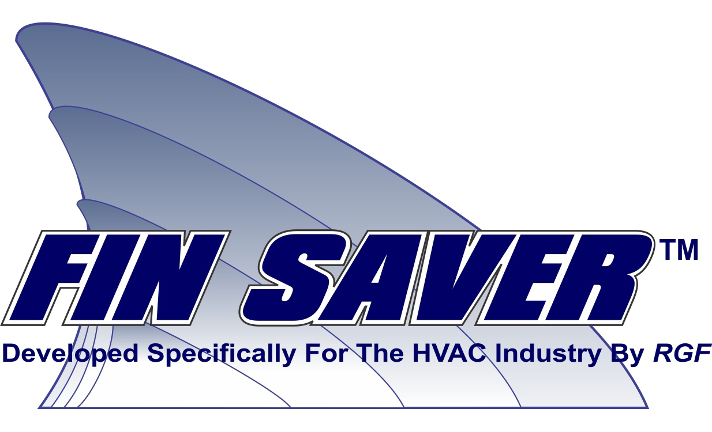

RGF Granted Patents for their Fin Saver™ Device

Riviera Beach, FL - RGF Environmental Group http://www.rgf.com and http://rgfairpurification.com, an environmental products manufacturer, announced that it has been issued three (3) new patents (Patent No. 8,999,138; Patent No. D668,739 S and Patent No. D668,738 S) for their Fin Saver™ device by the U.S. Patent and Trademark Office. The Fin Saver™ patents include an anodic device and method for reducing corrosion on objects subject to corrosion; methods associated with the use of such devices and unique ornamental design for the anodic device.

The Fin Saver was designed, engineered and is manufactured by RGF in the USA to fight galvanic and formicary corrosion in HVAC and refrigeration compressor lines, coils and fins. The Fin Saver™ comes in six different sizes, has 3.5 times the surface area and up to 2.5 times the weight of competitive ‘zincs’ for greater protection against corrosion. RGF’s patented design is specifically engineered for ease of installation in the HVAC and refrigeration market. Specialty zinc alloy is used for enhanced protection of both aluminum and copper components. The Fin Saver™ alloy has shown greater corrosion protection rates in salt spray testing (ASTM B-117) compared with typical marine-grade for boat ‘zincs’.

The high surface area of the Fin Saver™ is designed specifically to enhance condensation when mounted on cool lines. This enhanced condensation creates more electrolytic fluid, which creates a larger and more efficient path for the galvanic protection to occur. The electrolytic fluid works by increasing conductivity to the anode allowing more corrosive current to flow, which in turn promotes enhanced protection of the coils, fins and copper lines. The
Fin Saver™ also reduces or dampens vibration from equipment when attached to the line. Lab test prove a 65% reduction over lightweight boat zinc products.

According to Ron Fink, RGF’s President and CEO, “The Fin Saver™ is not just a standard shaft zinc for a boat that you buy at a boat store. Specifically designed for the HVAC/R industry, the Fin Saver offers up to 3.5 times the overall surface area and up to 2.5 times the weight versus competing boat zinc products. The greater the surface area and greater the weight, the more protection available.”
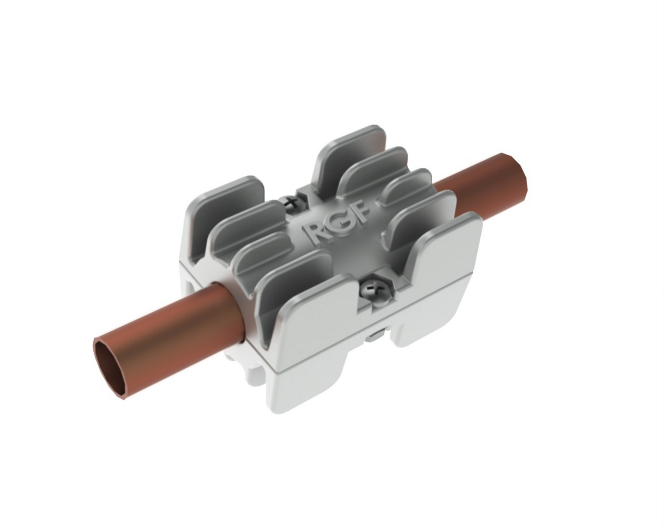
RGF Fin Saver™
U.S. Patent No. 8,999,138
U.S. Patent No. D668,739 S
U.S. Patent No. D668,738 S

RGF manufactures over 500 environmental products and has a 30-year history of providing the world with the safest air, water and food without the use of chemicals. RGF holds numerous other patents and patents-pending and previously invented the Guardian Air PHI-Cell® (Photohydroionization) and patent-pending REME-Halo both for the HVAC industry. RGF’s Advanced Oxidation Systems are proven and tested to be extremely effective in destroying mold, odors, bacteria and viruses while also being completely safe for occupants, and the REME-Halo has the added benefit of reducing particulates. For more information on the RGF Fin Saver™, visit our website at www.rgfairpurification.com or email requests@rgf.com.

RGF Environmental Group, 1101 West 13th St., Riviera Beach, Florida 33404.
Tel: (561) 848-1826 or (800) 842-7771; Fax: (561) 848-9454

